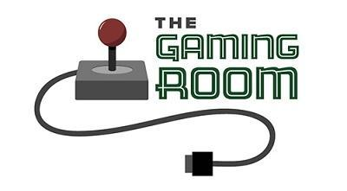

Draw it or Lose It

CS 230 Project Software Design Template
Version 1.0

Table of Contents

CS 230 Project Software Design Template 1
Table of Contents 2
Document Revision History 2
Executive Summary 3
Requirements 3
Design Constraints 3
System Architecture View 3
Domain Model 3
Evaluation 4
Recommendations 5

Document Revision History

Version | Date | Author | Comments
1.0 | 06/07/2026 | Jacob Carlson | Added Project two evaluation content and platform analysis.

Instructions
Fill in all bracketed information on page one (the cover page), in the Document Revision History table, and below each header. Under each header, remove the bracketed prompt and write your own paragraph response covering the indicated information.

Executive Summary

The Gaming Room has requested assistance in expanding its existing Android game, Draw It or Lose It, into a web-based application that can support multiple platforms and users. The goal of this project is to design a scalable and efficient software solution that allows players to participate from a variety of devices while maintaining a consistent user experience. The proposed solution uses object-oriented programming principles, unique identifiers for game elements, and software design patterns to ensure reliability and maintainability. By developing a web-based application, The Gaming Room will be able to reach a larger audience while supporting future growth and platform expansion.

Requirements

The application must support one or more teams, with each team containing multiple players. Game names and team names must remain unique to prevent duplication and confusion among users. Only one instance of the game may exist in memory at a time, requiring the use of the Singleton design pattern. The system must support unique identifiers for games, teams, and players while maintaining efficient storage and retrieval of game data. The application should also be scalable to support multiple users and platforms through a web-based environment.

Design Constraints

The primary design constraint is the requirement to convert an Android-only application into a web-based distributed environment that supports multiple platforms. The system must be scalable enough to handle many simultaneous users while maintaining acceptable performance and reliability. Security, network communication, and data consistency must also be considered because multiple clients will access the application through the internet. Cost constraints favor the use of open-source technologies where possible, while maintainability requires the use of established software design patterns and object-oriented programming principles. These constraints influence decisions regarding server architecture, platform compatibility, and software development tools.

System Architecture View

Please note: There is nothing required here for these projects, but this section serves as a reminder that describing the system and subsystem architecture present in the application, including physical components or tiers, may be required for other projects. A logical topology of the communication and storage aspects is also necessary to understand the overall architecture and should be provided.

Domain Model

The UML domain model illustrates the relationships between the Game, Team, and Player classes. A base Entity class is used to store common attributes such as unique identifiers and names, allowing other classes to inherit shared functionality. The Game class contains one or more Team objects, while each Team object contains one or more Player objects. This structure demonstrates inheritance, encapsulation, and code reuse through object-oriented design. The use of an Entity superclass reduces duplicate code and improves maintainability while supporting the software requirements for unique identifiers and organized game data management.

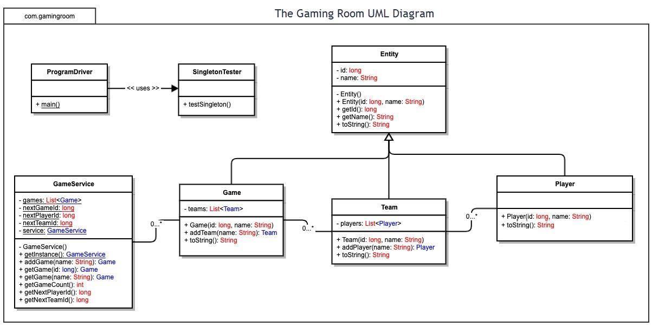

Evaluation

Using your experience to evaluate the characteristics, advantages, and weaknesses of each operating platform (Linux, Mac, and Windows) as well as mobile devices, consider the requirements outlined below and articulate your findings for each. As you complete the table, keep in mind your client’s requirements and look at the situation holistically, as it all has to work together.

In each cell, remove the bracketed prompt and write your own paragraph response covering the indicated information.

Development Requirements | Mac | Linux | Windows | Mobile Devices
Server Side | Mac can host a web-based application, but it is not commonly used for large-scale production servers. macOS provides a stable operating system with strong security features and support for web server software such as Apache and Nginx. However, Apple hardware is generally more expensive than alternatives and offers fewer hosting options in cloud environments. While Mac systems are reliable for development and testing, they are less cost-effective for hosting a web application that must support thousands of users. For The Gaming Room, macOS would be a functional but less practical server platform compared to Linux. | Linux is the best choice for hosting a web-based application. It is widely used in enterprise and cloud environments because it is reliable, secure, and cost-effective. Linux supports popular web server technologies such as Apache, Nginx, and Tomcat, and it can efficiently handle thousands of concurrent users. In addition, Linux has no licensing costs, which helps reduce operating expenses. Because of its scalability, performance, and strong community support, Linux would be the recommended server platform for The Gaming Room's web-based application. | Windows Server is a capable platform for hosting web-based applications and provides strong integration with Microsoft technologies. It supports Internet Information Services (IIS) and offers a familiar interface for organizations already using Microsoft products. However, Windows Server requires licensing fees, which increase overall costs. It also generally requires more system resources than Linux. While Windows can effectively host The Gaming Room application, it is typically more expensive and less flexible than Linux for large-scale web deployments. | Mobile devices are not designed to host large-scale web applications. Although modern smartphones and tablets are powerful, they lack the processing power, storage capacity, network reliability, and scalability needed to support thousands of users. Mobile devices are better suited for accessing applications rather than hosting them. For The Gaming Room, mobile devices should be used as client platforms while a dedicated server platform such as Linux hosts the web application.
Client Side | Supporting Mac users requires the application to be compatible with major web browsers such as Safari, Chrome, and Firefox. Because The Gaming Room will use a responsive web-based interface, development costs can be reduced by maintaining a single code base that works across platforms. Additional testing is required to ensure the application functions properly on macOS and different browser versions. While development time increases slightly due to cross-platform testing, a web-based approach makes supporting Mac clients efficient and cost-effective. | Supporting Linux clients requires browser compatibility with Chrome, Firefox, and other Linux-supported browsers. Since Linux distributions vary, additional testing may be necessary to ensure a consistent user experience. However, a responsive web application minimizes platform-specific development requirements. Development costs remain relatively low because the same web technologies can be used across operating systems, making Linux support practical without significant additional effort. | Windows is the most widely used desktop operating system, making it an important platform to support. A web-based application allows Windows users to access the game through standard web browsers without installing additional software. Development efforts should focus on compatibility with major browsers such as Chrome, Edge, and Firefox. While testing requirements may increase because of the large user base, the web-based design helps reduce development costs and simplifies maintenance. | Supporting mobile devices requires the application to function properly on both Android and iOS platforms. Developers must ensure that the user interface is responsive and optimized for smaller screens and touch-based controls. Additional testing is needed to verify compatibility across different devices and operating system versions. Although mobile support increases development time and testing requirements, it expands accessibility and allows more users to participate in the game from anywhere.
Development Tools | Development on macOS can be performed using tools such as Xcode, Visual Studio Code, Eclipse, and IntelliJ IDEA. Programming languages commonly used include Java, JavaScript, HTML, CSS, and SQL. macOS is particularly valuable because it supports the development and testing of both web applications and iOS-compatible software. While Apple hardware can increase costs, macOS provides a stable environment for software development and testing. | Linux supports a wide range of development tools including Visual Studio Code, Eclipse, IntelliJ IDEA, Git, Apache, Nginx, and MySQL. Common programming languages include Java, JavaScript, Python, HTML, CSS, and SQL. Linux is widely used in software development because it is open source, highly customizable, and cost-effective. Its strong support for web servers and cloud environments makes it an excellent platform for developing and deploying web-based applications. | Windows supports many development tools including Visual Studio, Visual Studio Code, Eclipse, IntelliJ IDEA, Git, and Microsoft SQL Server. Developers can use programming languages such as Java, C#, JavaScript, HTML, CSS, and SQL. Windows provides a familiar user interface and broad software compatibility, making it a popular choice for development teams. However, licensing costs may be higher than Linux-based environments. | Mobile application development requires tools such as Android Studio for Android devices and Xcode for iOS devices. Developers commonly use Java, Kotlin, Swift, JavaScript, HTML, and CSS when creating mobile-compatible applications. Additional testing tools are needed to verify performance across different devices, screen sizes, and operating system versions. Supporting mobile platforms increases development complexity, but it allows The Gaming Room to reach a larger audience and improve accessibility.

Recommendations

Analyze the characteristics of and techniques specific to various systems architectures and make a recommendation to The Gaming Room. Specifically, address the following:

- Operating Platform:
After reviewing the available operating platforms, I would recommend that The Gaming Room use a Linux-based operating system, specifically Ubuntu Server, to host the Draw It or Lose It application. Linux is a reliable, cost-effective platform that offers strong performance and security without the licensing costs associated with some other operating systems.
One of the biggest advantages of Linux is its ability to support applications across multiple environments. Since The Gaming Room wants to expand the game to different platforms and devices, Linux provides the flexibility needed to support that growth. It also works well with Java applications, making it a practical choice for the current software design. In addition, Linux is known for its stability and ability to handle multiple users efficiently, which is important for an online multiplayer game.

- Operating Systems Architectures:
For this application, a 64-bit client-server architecture would be the most effective solution. In this setup, the game server manages the application's data, user accounts, and game sessions, while players connect through their devices using a web browser or mobile application.
A 64-bit architecture allows the system to use more memory and process larger workloads than older 32-bit systems. This is especially important as the number of players increases over time. The client-server model also helps keep game information consistent for all users because the server acts as the central source of data. This architecture provides a solid foundation for future expansion while maintaining reliable performance.

- Storage Management:
To manage game data effectively, I recommend using a relational database management system such as MySQL. A centralized database would store player information, team names, game sessions, and other important application data.

Using a database helps ensure that information remains organized and accurate. It also reduces the risk of duplicate or inconsistent data appearing across different devices. Since Draw It or Lose It is expected to support multiple users simultaneously, a database management system provides the reliability and scalability needed to support future growth. Regular backups should also be implemented to help protect data in the event of a system failure.

- Memory Management:

Linux uses virtual memory management to efficiently allocate system resources to running applications. This allows the operating system to use both physical memory (RAM) and disk space when needed to keep applications running smoothly.

For Draw It or Lose It, this means the system can handle multiple players and active game sessions without significantly affecting performance. Linux also uses memory protection and process isolation techniques, which prevent one application from interfering with another. These features improve overall system stability and help ensure a better experience for users.

- Distributed Systems and Networks:
Since The Gaming Room wants the game to be available on multiple platforms, a distributed client-server model is the best approach. In this type of system, the game server handles processing and stores data while client devices communicate with the server over a network connection.
This design allows players using different operating systems and devices to participate in the same game session. Cloud hosting services could also be used to improve scalability and reliability. As the application grows, additional servers can be added to distribute workloads and maintain performance. Although network outages and connectivity issues are always potential concerns, implementing backup systems and monitoring tools can help minimize disruptions and improve availability.

- Security:

Security should be a major consideration for The Gaming Room as it expands the application to additional platforms. Linux provides several built-in security features, including user permissions, firewalls, and frequent security updates that help protect systems from unauthorized access.
To further protect user information, all communication between devices and servers should be encrypted using HTTPS. Passwords should be securely hashed before being stored in the database, and access to sensitive information should be restricted to authorized users only. Regular software updates and security monitoring should also be used to reduce vulnerabilities and help maintain the integrity of the system.

